sIffM !

ljifoM xfd|f] ;]/f]km]/f] k"0ff{ª\sM %)

k|yd q}dfl;s k/LIff @)*@

gfdM ;]S;gM /f]n g+=

………………. …………………….

lg/LIfs k/LIfs k|fKtfª\s………….

**k|=g+= !_ hf]8f ldnfpg'xf];\M -$_**

;d"x s ;d"x v

sfsf ug'{x'G5

xh'/a'af ;dfhsf] ;]jf a'afsf EffO{

cfJfZos u5'{

d 3/sf] sfd rflxg]

**k|= g+= @_sf]i7sdf lbOPsf zAb k|of]u u/L vfnL 7fpF eg{'xf];\M -$_**

-xh'/a'af, ;'vL, h'Qf, :d/0fzlSt, _

s_ d]/f a'afsf a'afnfO{ d ¯¯¯¯¯¯¯¯¯¯¯¯ eG5' .

v_ xfdL xfd|f ¯¯¯¯¯¯¯¯¯¯¯¯ ¥ofsdf /fVg'k5{ .

u_ ;hgfsf kl/jf/df ;a} hgf ¯¯¯¯¯¯¯¯¯¯¯¯ 5g\ .

3_ Wofgn] xfd|f] ¯¯¯¯¯¯¯¯¯¯¯¯ a9fpF5 .

**k|= g+= #_ l7s / a]l7s 5'6\ofpg'xf];\M -$_**

s_ xfdLn] ;fgfnfO{ dfof ug'{k5{ . [ ]

v_ xfdLn] xfd|f] ;fdfg l7s 7fpFdf /fVg'x'b}g . [ ]

u_ xfdLn] kf]if0fo'Qm vfg]s'/f vfg'k5{ . [ ]

3_ of]un] xfd|f] z/L/nfO{ :j:y /fV5 . [ ]

**k|= g+= $_ tnsf lrq x]/L gfd n]Vg'xf];\ M -$_**

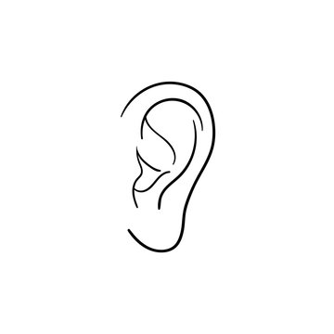 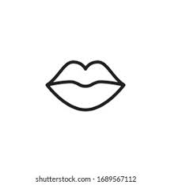

 

**k|=g+= %_ gfd n]Vg'xf];\M -*_**

**s_ s'g} b'O{ v]nf}gfx?**

**!_ @_**

**v_ s'g} b'O{ lzi6rf/ a'´fpg] zAbx?**

**!_ @_**

**u_ s'g} b'O{ cfˆgf ;fdfgx?**

**!_ @_**

**3_ s'g} b'O{ /fd|f afgLx¿**

**!_ @_**

**k|=g+= ^_ tnsf k|Zgx¿sf] pQ/ n]Vg'xf];\M -!)_**

s_ tkfO{+ slt sIffdf k9\g'x'G5 <

Ö ¯¯¯¯¯¯¯¯¯¯¯¯¯¯¯¯¯¯¯¯¯¯¯¯¯¯¯¯¯¯¯¯¯¯¯¯¯¯¯¯¯¯¯¯

v_ s:tf] vfg]s'/f :jf:Yosf nflu /fd|f x'Fb}g<

Ö ¯¯¯¯¯¯¯¯¯¯¯¯¯¯¯¯¯¯¯¯¯¯¯¯¯¯¯¯¯¯¯¯¯¯¯¯¯¯¯¯¯¯¯¯

u_ tkfO{+nfO{ dg kg]{ v]n s'g xf] <

Ö ¯¯¯¯¯¯¯¯¯¯¯¯¯¯¯¯¯¯¯¯¯¯¯¯¯¯¯¯¯¯¯¯¯¯¯¯¯¯¯¯¯¯¯¯

3_ tkfO{+sf sltcf]6f xft 5g\ <

Ö ¯¯¯¯¯¯¯¯¯¯¯¯¯¯¯¯¯¯¯¯¯¯¯¯¯¯¯¯¯¯¯¯¯¯¯¯¯¯¯¯¯¯¯¯

ª_ of]u ubf{ xfdLnfO{ s:tf] cg'ej x'G5<

Ö ¯¯¯¯¯¯¯¯¯¯¯¯¯¯¯¯¯¯¯¯¯¯¯¯¯¯¯¯¯¯¯¯¯¯¯¯¯¯¯¯¯¯¯¯

**k|= g+= &_ kf]ifs / kq' vfg]s'/fx¿sf] ;"rL agfpg'xf];\M -^_**

|  |  |
| --- | --- |
| kf]ifs vfg]s'/f | kq' vfg]s'/f |
|  |  |
|  |  |
|  |  |

**xfdL / xfd|f] v}/xgL**

**!_ :yfgLo If]qdf kfOg] s'g} kfFr cf]6f t/sf/Lx?sf] gfd n]Vg'xf];\M**

s_

v_

u_

3_

ª_

**@_**] **cfˆgf] 3/ / l5d]sdf pTkflbt s'g} kfFr cf]6f cGgx?sf] gfd n]Vg'xf];\M**

s_

v_

u_

3_

ª_

**;dfKt**